**Oxford Sofas**

| Faculty | TEHAMI FAISAL | |
| --- | --- | --- |
| Batch: | 2306D | |
| Group: | Oxford Sofas. | |
| Serial No. | Enrollment No. | Student Name. |
| 1. | 1489978 | Muhammad Taha |
| 2. | 1486781 | Muhammad Saeed |
| 3. | 1486336 | Laiba Abid |
| 4. | 1480503 | Nikita Ashok |

**Acknowledgement**

*The first, we would like to express my special thanks of gratitude to my teacher SIR TEHAMI FAISAL who helped a lot in finalizing this project within the limited time frame, valuable counseling and assistance for the accomplishment of this project.*

*Secondly, we would also like to thanks the e-project team at Aptech Head Office, who gave as the opportunity to do this interesting and wonderful project about Oxford Sofas*

*Thirdly, we also thank the e-project team for giving this task to us. Following are the benefits of this Project:*

* *Re-enforcement of skills happens in the experimental learning process.*
* *A mentor, ensuring that we do not get drifted, constantly guide us.*
* *It gives us a lot of confidence to face an interview as we have worked on a project. We can explain virtually everything on the subject we have learnt.*

**Synopsis**

*Welcome to* ***Oxford Sofas****, your ultimate online destination for best sofas! Whether you're an interior designer, a prospective buyer, or simply curious about the latest trends in the décor industry, we've got you covered.*

*At* ***Oxford Sofas****, we strive to provide you with comprehensive and up-to-date information on a wide range of sofa. Our expert team of Designers are passionate about sofa and are dedicated to bringing you the latest designs*

*Explore our extensive Inventory of sofa sets, where you can find detailed specifications. We've got all the details you need to make an informed decision.*

*But* ***Oxford Sofas*** *is more than just a repository of facts and figures. We also understand the emotional connection people have with their furniture. From watching movies and having gossips, our sofas are the best way to make memories on them. We aim to provide you a wide variety of luxurious and breathtaking designs.*

*Moreover, whether you're seeking advice on maintenance and interior designs, want to showcase your own furniture, or simply want to engage in friendly banter, our community is a great place to connect with fellow interior lovers.*

*Stay up to date with the latest furniture events and launches through our news section. We bring you the latest happenings from the world of sofas. You'll also find expert analysis, industry trends, and insightful opinion pieces to keep you informed and engaged.*

*At* ***Oxford Sofas****, we believe that buying a sofa should be an enjoyable and hassle-free experience. That's why we provide tools and resources to assist you in your interior shopping journey. So, if you’re seeking information about design about your interior* ***Oxford Sofas*** *is your go-to destination.*

*Problems Definition*

*The* ***‘Oxford Sofas’*** *is largest online sofa market. This initiative is aimed towards providing information and details about Sofas to buyers.*

*The site provides details and specifications of various models offered by the companies. It also provides pictures and images to have a better look.*

***‘Oxford Sofas’*** *is looking to restructure the entire website to provide information and also connect with prospective customers.*

*Customer Requirement Specification (CRS)*

*1) The Home Page should be created making use of Sections with a suitable logo, the header section can be added which will show images sofas.*

*2) The site must contain the links to navigate through any category for the information.*

*3) The site should display a menu which will contain the options for brief introduction about the various sofas available, location of the shop and any other information if required.*

*4) The information should be categorized according to the brand names of the sofas like if a User wants to see only “grand” sofas or any other companies’ sofas then he/she can click on a Link/button/menu etc and can see only that Brand sofas.*

*5) When a user selects any particular brand, a list of sofas for that brand will be displayed*

*6) A brief summary of features of the sofas should be displayed on the Web Page along with the picture but detailed Features should be stored in Individual Word documents which can be downloaded or viewed by the User who wishes to see the same.*

*7) The user should also be able to compare the various sofas of different as well as similar brands.*

*8) There should be a “Contact Us” page which will have the Address of the Company which should be displayed using Geolocation API (e.g. Google Maps) and the email address which when clicked will invoke the local mail client from where they can send an email.*

***Task Sheet***

| **Project Ref.No:**  **Ep/Advertisement**  **Portal Management**  **System /01** | | **ProjectTitle** | **Date Of preparation Of Activity Plan** | | | |
| --- | --- | --- | --- | --- | --- | --- |
| No. | ***Task*** | **O**  **X**  **F**  **O**  **R**  **D**  **S**  **O**  **F**  **A**  **S** | ***Actual***  ***Start Date*** | ***Actual Days*** | ***Team-Mate***  ***Name*** | ***Status*** |
| 01. | ***Home page*** | 2  5  -  O  C  T  O  B  E  R  -  2023 | 3  0  -  D  A  Y  S  - | M.Taha | *A* |
| 02. | ***Categories pages*** | M.Taha / Laiba | *a* |
| 03. | ***About page*** | Laiba | *a* |
| 04. | ***Contact page*** | M.Saeed | *a* |
| 05. | ***Collecting Pictures*** | Nikita | *a* |

Screenshots

1. Nav Bar



1. Home Page

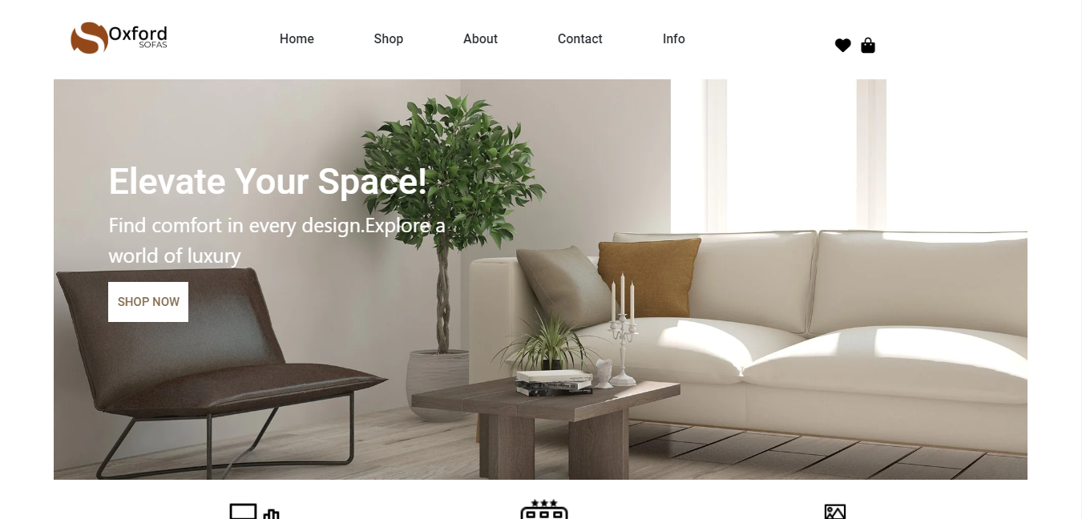

1. New Arrival

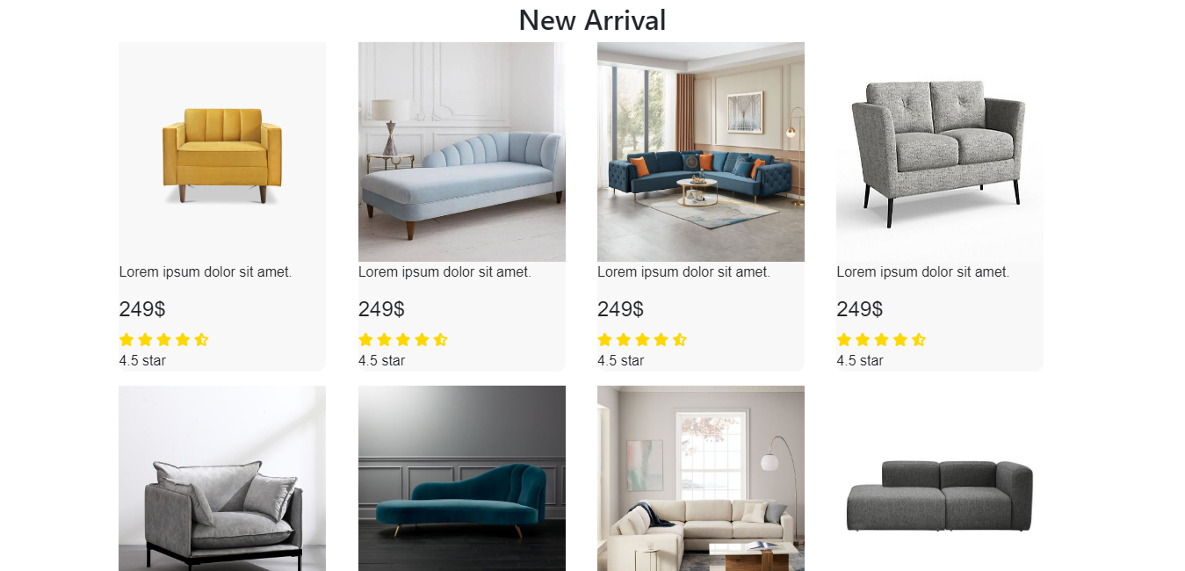

1. Featured Products

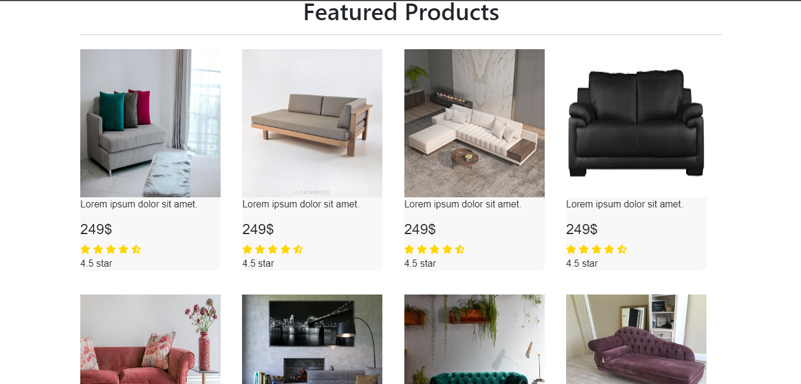

1. Footer



1. Contact Page

